DONOR WALL & VETERAN MEMORIAL GARDEN BRICK ORDER FORM | 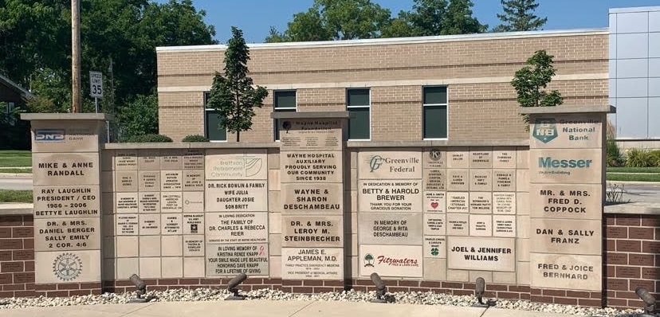
We invite you to commemorate your family, loved ones, and company by becoming a partner in shaping community healthcare for the future in support of the Wayne HealthCare Foundation at Wayne HealthCare.

- Fill out the information below (maximum 14 per line). 2. Choose brick/block size and display option.

Fourth Line
for 12x18 blocks only

I would like this 4x8 brick displayed in the Veteran’s Memorial Garden Pathway

I would like this brick/block displayed on the Foundation Donor Wall (select one/order form, no limit on numbers of blocks ordered)
4x8 Wall Brick 12x18 Block
(only 6 available)

BRICK PRICES:
- Veteran Memorial Bricks are a $100 donation, please list Veteran’s Name, Rank, Branch of Service and Dates served (years)
- Donor Wall: 4x8 bricks are a $100 donation & 12x18 blocks are $750. Blocks are gray limestone. For logos/color add a $60 additional donation.

Purchaser’s Name: Phone Number:

Address:

Date: Email: __________________________________________________________

Payment Method: Cash/Check (make payable to Wayne HealthCare Foundation) Credit Card (all donations are tax deductible)
For Credit Card Payment Method Only, pay online at www.waynehealthcare.org/foundation
Mail to Wayne HealthCare Foundation, 835 Sweitzer Street, Greenville, OH 45331
Call Lauren Henry, Foundation Executive Director at 937-569-6408 or email lauren.henry@waynehealthcare.org with any questions.

