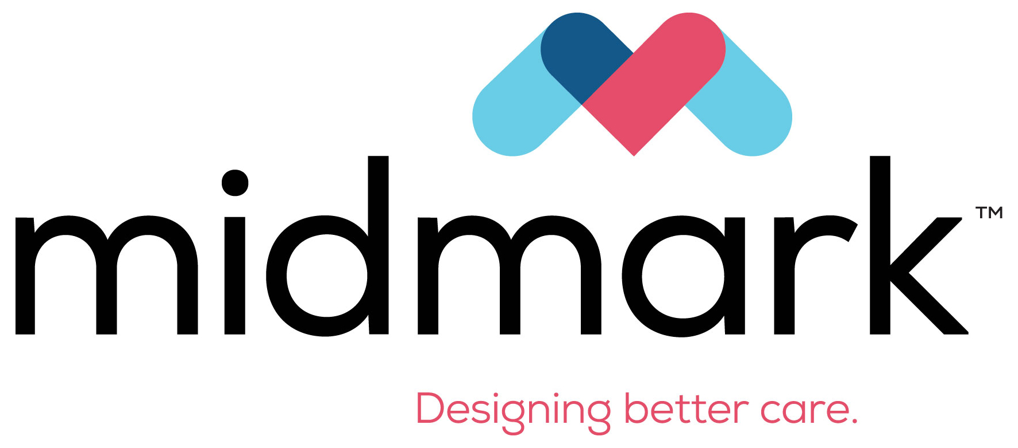
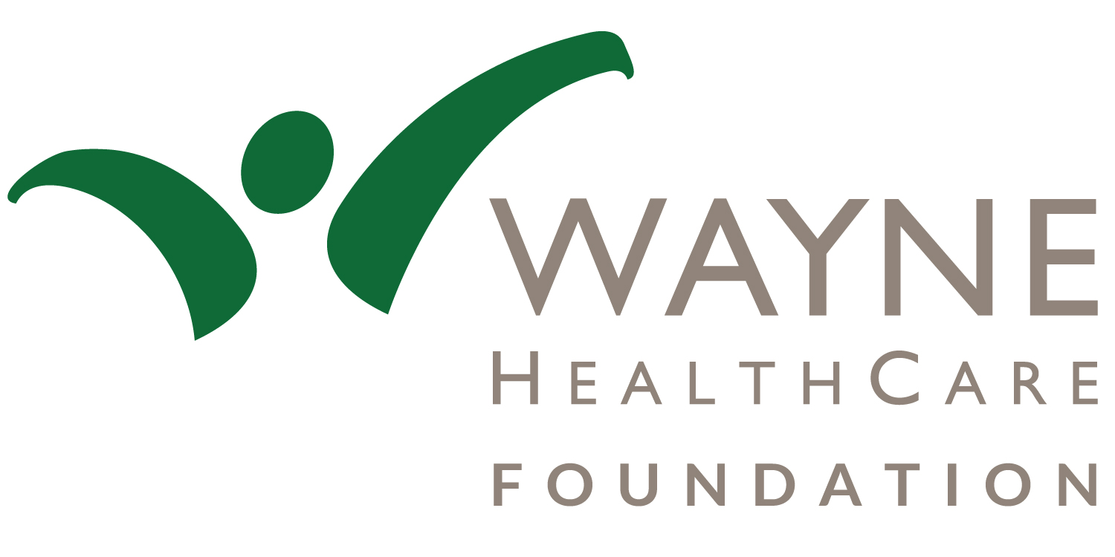
Wayne HealthCare Foundation in Partnership with Midmark Corporation & Spirit Medical Transport have AEDs & training available to 501(c)3 organizations & other non-profits.
AED (Automatic External Defibrillator) Grant Request
Date of Request:

Legal Name of Organization: _

Tax Exempt Status: 501(c)(3) Organization ______________ Tax ID Number:
Other (specify)
(Please provide a copy of your IRS determination letter with this request)

Year organization was founded: Director:

Address:

Phone Number: Email Address:

Contact Person: Contact Phone Number:

Request Amount: Type of Request:

Reason for Request:

Mission:

Does the organization have an identified medical director for the AED program?

Name of Physician:

To have an AED on site, you are required to have staff or volunteers trained in CPR and the monitor use.
Please list names and dates of CPR training for your personnel:
Date | Name | Date | Name
* Spirit Medical Transport has offered to provide this training to your organization through a voucher program for up to ten participants. Contact Brian Hathaway at 548-2800.

To have an AED on site, your organization is required to notify in writing the rescue squad that covers your area of the existence of an AED. Please attach a copy of the letter you intend to send to the appropriate rescue squad with this application.

Requests are evaluated based on our mission statement and granted on a first come, first serve basis, so please let us know of your needs quickly. Your organization, Wayne HealthCare Foundation & Midmark Corporation will share the cost, 1/3 each of the AED.

The above information is true and we hold harmless Wayne HealthCare Foundation, Midmark Corporation, and Spirit Medical Transport in any activity associated with this AED program. This AED is now property of the applying organization and will be maintained by the applying organization. Signature of representative:________________________________ Date:_________

Wayne HealthCare Foundation Use Only:
- 501(c)(3) status confirmed – IRS Publication 78 Grant Agreement executed
copy of IRS determination letter obtained Date Paid:_________________
certificate of non-termination obtained Check Number: ____________
“Collaborating through philanthropy with Wayne HealthCare in order to enhance community education and wellness close to home.”

